Synapse Test Plan

**Revision History**

|  |  |  |  |
| --- | --- | --- | --- |
| **Rev** | **Date** | **Author** | **Description** |
| 1.0 | 5/1/12 | Mark Mecham | Release Version |

**Document Approvers & Sign-Off**

|  |  |  |  |
| --- | --- | --- | --- |
| **Date** | **Approver** | **Role** | **Document Accept/Reject** |
| 5/1/12 | Glenn Curtis | Dev Manager | Accept |

**Synapse SW Contacts**

|  |  |  |
| --- | --- | --- |
| Name | Role | Contact Information |
| Mark Mecham | QA Manager | [Mark.Mecham@synapse.com](mailto:Mark.Mecham@synapse.com) |
| Ric Merrfield | Sr Business Architect | [Ric.Merrifield@syapse.com](mailto:Ric.Merrifield@syapse.com) |
| Tim Sharpe | Software Test Lead | [Tim.Sharpe@synapse.com](mailto:Tim.Sharpe@synapse.com) |
| Manny Vellon | CTO | [Manny.Vellon@synapse.com](mailto:Manny.Vellon@synapse.com) |
| Glenn Curtis | Development Manager | [Glennc@synapse.com](mailto:Glennc@synapse.com) |
| Arek Glabek | Sr Developer (xBRMS, xBRC) | [Arek.Glabek@synapse.com](mailto:Arek.Glabek@synapse.com) |
| Amar Terzic | Data Architect (xi) | [Amar.Terzic@synapse.com](mailto:Amar.Terzic@synapse.com) |
| Robert Lantry | Sr Developer (IDMS) | [Robert.Lantry@synapse.com](mailto:Robert.Lantry@synapse.com) |
| Iwona Glabek | Sr Developer (xi, Security) | [iwona.glabek@synapse.com](mailto:iwona.glabek@synapse.com) |
| Ted Crane | Sr Developer (GxP / UIE integration) | [Ted.Crane@synapse.com](mailto:Ted.Crane@synapse.com) |
| Neal Oman | Sr Developer (xi) | [Neal.Oman@synapse.com](mailto:Neal.Oman@synapse.com) |
| Rob Silvernagel | SDE/T (xBRMS, Integration Testing) | [Rob.Silvernagel@synapse.com](mailto:Rob.Silvernagel@synapse.com) |
| Stephen Madson | Sr Java Scripter, SDE/T (IDMS, xi) | [Stephen.Madson@synapse.com](mailto:Stephen.Madson@synapse.com) |
| Joe Ferrara | SDE/T (xTP, xBR) | [Joe.Ferrara@synapse.com](mailto:Joe.Ferrara@synapse.com) |

**Synapse HW Contacts**

|  |  |  |
| --- | --- | --- |
| Name | Role | Contact Information |
| Jonathan Kling | Global Oversite - Synapse | [Jonathan.Kling@synapse.com](mailto:Jonathan.Kling@synapse.com) |
| John Stiehl | Lead Program Manager | [John.Stiehl@synapse.com](mailto:John.Stiehl@synapse.com) |
| Larry Kulesa | Project Manager (xBR) | [Larry.Kulesa@synapse.com](mailto:Larry.Kulesa@synapse.com) |
| Mike Simick | Lead Program Manager (Infrastructure) | [Mike.Simick@synapse.com](mailto:Mike.Simick@synapse.com) |
| Burt Buxton | EE Lead (xBR) | [Burt.Buxton@synapse.com](mailto:Burt.Buxton@synapse.com) |
| Mike Wilson | SW Developer (xBR) | Mike.Wilson@synapse.com |
| Brian Piquette | EE Lead (xTP) | [Brian.Piquette@synapse.com](mailto:Brian.Piquette@synapse.com) |
| Greg Strange | SW Lead (xTP) | [Greg@synapse.com](mailto:Greg@synapse.com) |
| Jacques Lincoln | Program Manager (Infrastructure) | [Jacques.Lincoln@synapse.com](mailto:Jacques.Lincoln@synapse.com) |
| Morgan Robinson | Program Manager (xTP) | [Morgan.Robinson@synapse.com](mailto:Morgan.Robinson@synapse.com) |
| Andy Breuninger | SW Development Lead (xBR) | [Andy.Breuninger@synapse.com](mailto:Andy.Breuninger@synapse.com) |
| Skip Kaczynski | SW Developer (xBR) | [Skip.Kaczynski@synapse.com](mailto:Skip.Kaczynski@synapse.com) |
| Goran Lynch | Program Manager (Infrastructure) | [Goran.Lynch@synpase.com](mailto:Goran.Lynch@synpase.com) |
| Mike Sawicki | Program Manager (Infrastructure) | Mikes@synapse.com |
| Tom Christoe | Program Manager (Infrastructure) | Tomc@synapse.com |

**NGE and External Contact List**

|  |  |  |
| --- | --- | --- |
| Name | Group – Role | Contact Information |
| Michael Jungen | NGE xBand Module Leader | [Michael.G.Jungen@disney.com](mailto:Michael.G.Jungen@disney.com) |
| Bart Butler | GxP – GFF Module Leader | [Bart.Butler@disney.com](mailto:Bart.Butler@disney.com) |
| Kristin Ong | Manager, Experience Integration | [Kristin.Ong@email.disney.com](mailto:Kristin.Ong@email.disney.com) |
| Mark Lewis | xBMS Module Leader | [Mark.Lewis@disney.com](mailto:Mark.Lewis@disney.com) |
| Rich Criado | Manager, Experience Development | [Richard.J.Criado@email.disney.com](mailto:Richard.J.Criado@email.disney.com) |
| Bonnie Spivey | NGE Business Analyst | [Bonnie.J.Spivey@disney.com](mailto:Bonnie.J.Spivey@disney.com) |
| Jennifer Fishpool | xi Module Leader | [Jennifer.P.Fishpool@disney.com](mailto:Jennifer.P.Fishpool@disney.com) |
| Nate Ivey | xi Analytics | [Nathan.J.Ivey@disney.com](mailto:Nathan.J.Ivey@disney.com) |
| Bo Rankin | xi Program Manager | [John.Rankin@email.disney.com](mailto:John.Rankin@email.disney.com) |
| Todd Heard | xi Technical Lead | [Todd.Heard@email.disney.com](mailto:Todd.Heard@email.disney.com) |
| John Dauphiny | Systems Architect - Experience Development | John.L.Dauphiny@disney.com |
| Adam Parish | NGE Technical PM | [Adam.S.Parish@disney.com](mailto:Adam.S.Parish@disney.com) |
| Bonnie Spivey | GxP Business Analyst | [Bonnie.J.Spivey@email.disney.com](mailto:Bonnie.J.Spivey@email.disney.com) |
| Pam Defrancesco | NGE Infrastructure Lead | [Pam.H.Defrancesco@disney.com](mailto:Pam.H.Defrancesco@disney.com) |
| David Patrolia | Park Entry QA | [David.Patrolia@disney.com](mailto:David.Patrolia@disney.com) |
| Andreas Schmidt | GxP - Dev Performance Lead | [andreas.d.schmidt@accenture.com](mailto:andreas.d.schmidt@accenture.com) |
| Brad Sokola | GxP - Developer | [bradley.p.collins@accenture.com](mailto:bradley.p.collins@accenture.com) |
| Robert Lindley | GxP – Developer | [robert.a.lindley@accenture.com](mailto:robert.a.lindley@accenture.com) |
| Travis Beacon | UIE – COO | [travis@uievolution.com](mailto:travis@uievolution.com) |
| Frank Jewitt | UIE – Dir Product Development | [frank@uievolution.com](mailto:frank@uievolution.com) |
| Rich Alford | UIE – QA Lead | [ralford@uievolution.com](mailto:ralford@uievolution.com) |
| Cecile Tron | UIE - Architect | [ctron@uievolution.com](mailto:ctron@uievolution.com) |
| David Gross | DCL Program Lead | [David.Gross@disney.com](mailto:David.Gross@disney.com) |
| Michelle Bentubo | DCL Business Leadership | [Michelle.Bentubo@disney.com](mailto:Michelle.Bentubo@disney.com) |
| Scott Henderson | DCL – Tech Product Owner | [Scott.Henderson@disney.com](mailto:Scott.Henderson@disney.com) |
| David Decurtis | GFF, CDA Application | [david@decurtis.com](mailto:david@decurtis.com) |
| Paul Butler | Lumadigm - CTO | [pbutler@lumidigm.com](mailto:pbutler@lumidigm.com) |
| Brad Collins | GxP Test Lead | bradley.p.collins@accenture.com |
| Kathy Fawcett | NGE Test Lead | [Kathy.M.Fawcett.-ND@disney.com](mailto:Kathy.M.Fawcett.-ND@disney.com) |
| John Wetzel | Trifecta - Sr. Technical Architect | [John.X.Wetzel.-ND@disney.com](mailto:John.X.Wetzel.-ND@disney.com) |
| Dan Markey | Trifecta | [dkm@trifecta.com](mailto:dkm@trifecta.com) |
| Adam Leonards | Frog Design | [adam.leonards@frogdesign.com](mailto:adam.leonards@frogdesign.com) |
| Evhen Farmiga | GBTS Networking | [Evhen.M.Farmiga@disney.com](mailto:Evhen.M.Farmiga@disney.com) |
| David Mattice | NGE Networking | Dave.J.Mattice.-ND@disney.com |
| Randy Brooks | NGE Common Utilities – Exec Sponsor | [Randy.Brooks@disney.com](mailto:Randy.Brooks@disney.com) |
| Frank Ivan | Four Winds Interactive | fivan@fourwindsinteractive.com |
| Doug Levitt | Four Winds Interactive | [dlevitt@fourwindsinteractive.com](mailto:dlevitt@fourwindsinteractive.com) |
| Aaron Bach | Four Winds Interactive | abach@fourwindsinteractive.com |

Table of Contents

1 NGE Background 10

1.1 High Level Release Schedule for NGE Release R1.0 12

2 Audience 13

3 Related Documents 14

4 Overview 15

5 GxP Test & Survey Architecture 16

5.1 GxP Test & Survey 22

5.2 GxP Test & Survey Schedule 24

6 Park Entry Pilot (July / August 2012) 24

6.1 Park Entry Schedule 25

7 Test Track Pilot (July 2012) 25

8 GFF Pilot - Be Our Guest (Nov 2012) 26

9 Test Objectives & Methodology 26

9.1 Test Objectives 26

9.2 Test Planning and Preparation, Key Activities & Tasks 26

9.3 V-Model 27

9.4 Test Planning Documents 28

10 Build Process 28

10.1 Synapse Builds 28

10.2 Setup of the xConnect System 29

11 Test Automation 30

12 Other Test Documents 30

12.1 xBand (xB) 30

12.2 xBand Touch Point (xTP) 32

12.3 xBand Reader Controller (xBRC ) 32

12.4 xBand Reader Management System (xBRMS ) 35

12.5 Identity Management System (IDMS) 36

13 Test Types 37

14 NGE Testing 38

14.1 Core NGE Test Phases 39

14.2 Other Test Phases @ NGE 39

14.3 NGE Build and Configuration Management 39

15 NGE Test Environments 40

15.1 Alpha Lab (Disney Staging Lab) 40

15.2 Testing Environment Descriptions 40

16 Synapse Test Environments 42

16.1 Build Verification Environment (BVT) 42

16.2 System Integration Testing (SIT) 42

16.3 Integration Testing (INT) 43

16.4 Functional Tests / UAT (User Acceptance Tests) 44

16.5 Load & Performance Testing 45

16.5.1 Test Description & Objective 45

16.5.2 Load Testing 45

17 Disney Environments 47

17.1 Alpha Lab 47

17.2 Park LDU 47

17.2.1 In Park Testing for GxP Pilot and Survey 48

18 Release Criteria for GxP Test & Survey 49

19 Regression Testing 49

20 GxP Test & Survey Timeline 50

21 Test Roles & Responsibilities 51

22 Test Setup 52

23 Test Environments & Labs 52

23.1.1 Test Management Tool 52

23.1.2 Test Automation Tool 52

23.1.3 Performance Test Tool 52

24 Test Data 52

25 Configuration Management 53

26 Test Control 53

26.1 Defect / Issue Management 53

26.2 Change Request Management 53

27 Acronyms / Definitions 55

# NGE Background

Next Generation Experience (NGE) is a new Disney program that includes a number of new systems, both hardware and software that will change the way a guest interacts with Walt Disney Parks and Resorts. The overall goal of NGE is to make your trip easier, from prebooking your experiences to keeping guests in the park longer.

Synapse is responsible for building out the hardware and software around the *MagicBand*, formally known as xBand.

**xConnect (Experience Connect)**

**My Magic+** is supported by a first of a kind “experience connection system” linking Guest interactions across physical and virtual spaces to core NGE and GBTS systems.

Created as a unified system, each component functions harmoniously together from a technological, industrial and human ergonomic design perspective. Experience Connect is configurable to virtually any experience environment.

**xBand (external name MagicBand)**

xBand provides universal identification short and long range RF capabilities. An innovative and patented one-size-fits all design allows singular applicability to all Guests. The xBand contains a HF tag that allows short range contactless reads and a coin cell operated 2.4 GHz RF transceiver to trigger Experience Magic.

**xTP (xBand Touch Point)**

The touch point is the xBand compliment for short-range contactless interactions. As the ubiquitous **My Magic+** icon presents itself across the park, the touch point creates an intuitive and consistent Guest interaction method. With configurable lenses, hardware, light sensors and audio cues, the touch point is capable of being integrated into the different themed environments.

**xBR (xBand Reader)**

The main application function of the xBR is to receive long range reads from the xBand. The xBR then communicates events received from the xBR to the xBRC

The xBR contains 8 receive radios, 1 transmit radio, microcontrollers, with Ethernet and USB connection. Power if provided by PoE. The xBand reader uses interchangeable antennas applicable to unique environments and requirements.

**xBRC (xBand Reader Controller)**

xBRCs receive events from xBRs and xTPs and perform various data processing tasks to translate these events into forms more usable by downstream applications.

**xDAP (xBand Disney Access Portal) or DAP**

The Disney Access Portal is an integration of Experience Connect components that eliminates turnstiles and enables a new theme park arrival process. The Access Portal contains a state-of-the-art biometric scanner tied to the touch point improving security and reducing error rates.

A MagicBand is worn on a guest’s wrist and contains an RF Radio that communicates with both short and long range readers. These readers are referred to as xTP (short range reader) and xBR (long range reader).

The NGE experience starts with the MagicBand. The band becomes the main interface with how a guest enters the park (touch to enter), is tracked in a queue (xTP / xBR), or on an attraction (xBR), pays for items (touch to pay) as well as a variety of other activities.

The target audience for the first release will be guests staying at Walt Disney World Deluxe Resorts.

**NGE & other Disney Groups (partial list)**

* **xBMS** – xBand Management System – Procurement and Distribution of the MagicBands. One of the main functions of xBMS is to associate the Guest to their MagicBand.
* **GxP** – Guaranteed Experiences – Guests can pre-reserve attractions with a FastPass+ (next generation FastPass), schedule a Character Meet and Greet, and reserve dining through Great Food Fast (GFF) program.
* **xi** – Experience Intelligence – set of functionality that will gather and interpret data from the xConnect system.
* **MyDisneyExperience (Formerly PEP – the Personal Experience Portal)** – The program used by the guest to schedule their entitlements and plan their trip. PEP can be accessed via Mobile, Kiosk or PC.
* **RTI / SF OV –** RTI and OneView allow NGE modules and homebase systems (legacy) to communicate with each other.
* **GBTS** – Global Business Technology Services (Disney IT)
* **Homebase Systems –** Systems developed and managed by GBTS that support backend operations
* **POS –** Point of Sale.
* **Dreams –** Reservations
* **ATS –** Ticketing.
* **OneSource –** Theme Park Information.
* **Accovia –** Disney Travel System.
* **DME –** Disney Magical Express.
* **DCL** – Disney Cruise Lines.

**External Partners (partial)**

* UI Evolution – Mobile Cast App being used at DME for GxP Test & Survey.
* Trifecta – Park Entry software & Email Server used by UIE Cast App in the GxP Test & Survey
* DeCurtis – GFF (Great Food Fast) and DCA Application used on DCL. Neither are part of the GxP Test and Survey.
* Four Winds Interactive – Software running on Kiosk Player in Park. Used to display Guest Entitlements when a guest touches their MagicBand or RFID Card (GxP Test & Survey)

## High Level Release Schedule for NGE Release R1.0

NGE development will be done via an Agile Scrum methodology. These developed components will be delivered into and iterative test methodology

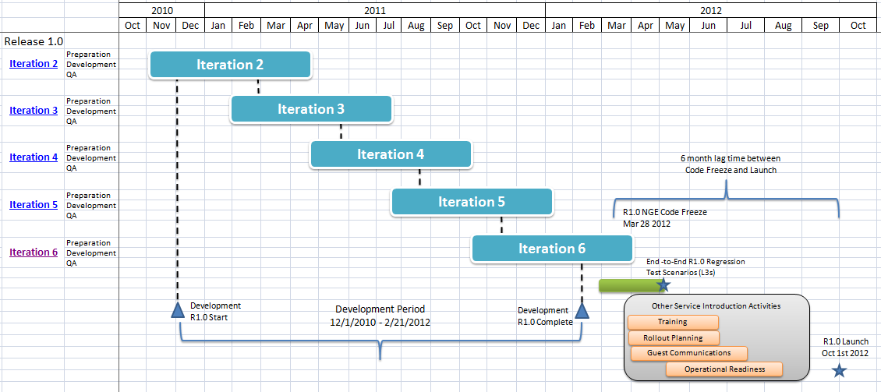

**Figure 1 – High Level Release Schedule**

Iteration 7 (three sprints)  
Start – 2/29/12

End – 5/22/12

Iteration 8 (two sprints)

Start – June 1, 2012 (?)

End – July 31, 2012 (?)

NGE Production Test Release Schedule

|  |  |  |  |  |  |  |  |  |  |  |  |  |  |  |  |  |  |  |  |  |  |  |  |  |  |
| --- | --- | --- | --- | --- | --- | --- | --- | --- | --- | --- | --- | --- | --- | --- | --- | --- | --- | --- | --- | --- | --- | --- | --- | --- | --- |
| |  |  |  |  |  |  |  |  |  |  |  |  |  |  |  |  |  |  |  |  |  | | --- | --- | --- | --- | --- | --- | --- | --- | --- | --- | --- | --- | --- | --- | --- | --- | --- | --- | --- | --- | --- | | |  |  |  | | --- | --- | --- | |  | Start | End | | NGE R1.0 | 14-Nov | 17-Feb | | NGE R1.1 | 20-Feb | 2-Jun | | NGE R1.2 | 4-Jun | 27-Jul | | NGE R1.3 | 29-Jul | 5-Oct | | NGE R1.4 | 8-Oct | 1-Jan | |  |  | |  |  |  | |  |

# Audience

This document is intended to be consumed by the following groups and organizations within Synapse and Walt Disney Parks and Resorts.

| ***Group/Organization*** | ***Goal*** |
| --- | --- |
| Synapse Team | To understand the overall testing approach and release strategy that will support xBand Reader (xBR), xBand Reader Controller (xBRC), Identity Management System (IDMS) and xBand Reader Management System (xBRMS). |
| NGE xBMS Team | To understand the overall testing approach and release strategy that will support the xBMS. |
| NGE GxP Team | To understand the overall testing approach and timelines that will support the GxP implementation. |
| NGE xi Team | To understand the overall testing approach and timelines that will support the xi implementation. |
| UIE Cast App Team | To understand the testing scope and phases that will be included as part of the UIE Mobile Cast App implementation. |

# Related Documents

| Document | Description |
| --- | --- |
| xBR Interface Control (ICD) | Describes the network interfaces to the long range reader or xBR. |
| xBRC Interface Control (ICD) | Describes the interfaces between xBRC and the xBRs /xTPs |
| xTP Interface Control (ICD) | Describes the interfaces that allow the xTP to talk to the xBRC. |
| xBand Reader Management System (xBRMS) Architecture | The xBand Reader Management System (xBRMS) manages xBRC configs, allows for guest search, can monitor health of system |
| xBRMS Design | High level design of xBRMS functionality. |
| xBRMS User Interface | Describes UI for xBRMS. |
| xBRC High Level Technical Design | High level design of xConnect system. |
| xBRC Internal Design | Identify the xBRCs main areas of functionality, configuration, installation, and UI. |
| xBand System Architecture | Provides context to the operation of the xBR |
| xBRC High Availability Options | This document describes various strategies for providing high availability (HA) xBRCs for NGE. |
| xBand System Requirements v2.4 | Provides requirements for the system. |
| NGE Data Architecture | Provides external systems interfaces |
| Queue Metrics High Level Design | Provides details on visualization aspects. |
| xBRC, IDMS, xBRMS, xTP | Test Plans for these components. |
| NGE Alpha Lab Installation | Describes the installation of Synapse components at the Alpha Lab (NGE Staging Lab). |

# Overview

The purpose of the Synapse Test Plan is to provide a high level test approach to support testing of the software components being created and deployed for **GxP Test and Survey Pilot**. Synapse is delivering both hardware and software to NGE.

Synapse Software in GxP Survey & Test:

xBRC, xBRMS, IDMS and xi make up the Synapse software modules.

Hardware used in GxP Survey & Test:

xTP - The short range reader, where TP = Touch Point.

RFID Cards from CPI

The document explains test objectives, test stages, and various other test setup items that will need to be in place in order to execute a successful test phase. This document does not cover testing of the hardware but does point to those test plans.

The objective of the Synapse Test Plan is to capture & provide visibility to all attributes describing a MagicBand worn by a guest. The xBand Reader (xBR) and the xTP (short range touch point) will communicate to the xBand Reader Controller (xBRC) and send JMS messages to the ESB (Enterprises Service Bus) when they can be consumed by the other NGE modules.

The main functionality that will be implemented includes:

* Demonstrate that a MagicBand can be read by both xTPs and xBRs (post GxP Test and Survey).
* Integrate xBR and xTP with the xBRC which then sends JMS messages to the ESB
* Show that the xBRC can “Singulate” a Magic Band in a Queue, on an Attraction, and other Disney defined area like in a restaurant with the GFF (Great Food Fast ) program.
* Through the UI, allow the end user to configure, calibrate, and monitor xBRC(s) from the xBRMS.
* Leverage the IDMS as both a storage and guest-to-entitlement system for the GxP Test and Survey.

# GxP Test & Survey Architecture

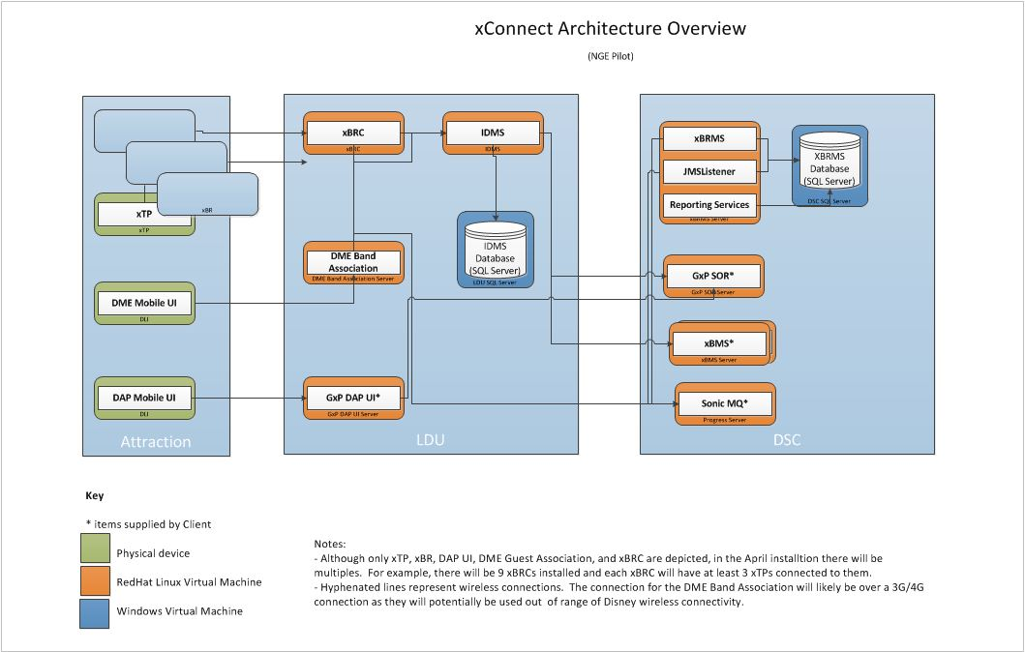

**Figure 2 – Architecture Overview**

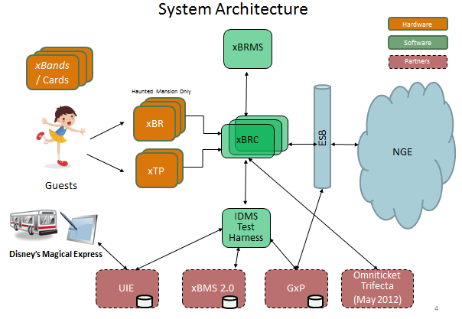

‘**Figure 3 – System Architecture**

# High Level Descriptions of the Main Components of GxP Test & Survey and Park Entry

**xTP TouchPoint (Short Range Reader)**

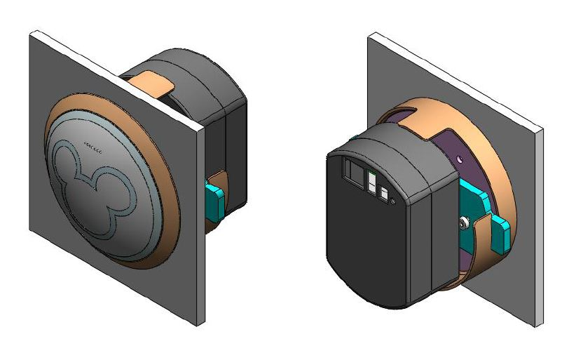

Composed of two components:

xTP (customer-facing circular domed touch plate with LED and sound feedback to customer actions)

xTPE (interior controlling component)

Ethernet connectivity & Direct current required

**xBR (Long Range Reader)**

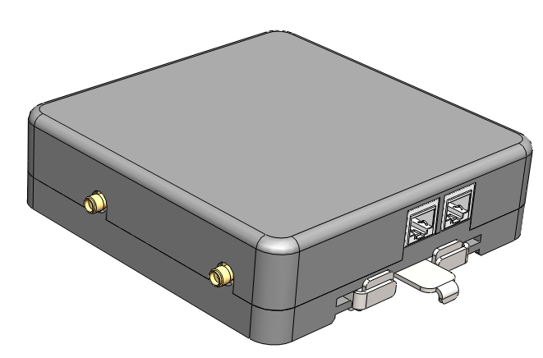Two Receive Channels, One Transmit Channel

Ethernet Connectivity

Power over Ethernet or Direct Current

For this Test Plan, the following acronyms are used:

* xBand or MagicBand: RFID device worn by Guests.
* xBR: long range RFID reader with uni- or omni-directional antennae.
* xTP: Experience TouchPoint, a Disney-themed short range RFID reader or “touch” device.
* xBRC: code package that manages xBRs, xTPs, and DAP devices.
* xBRMS: code and database which stores operational data.
* DAP: Disney Access Portal, an xTP configured with a biometric reader.
* IDMS: code and database storing Guest and xBand information.
* xConnect: code, scripts, APIs, and database schemas which comprise the unifying messaging, management, and reporting software which ties the hardware together into a coherent solution.

|  |  |
| --- | --- |
| xBand (xB) | xBand or MagicBand is worn on the wrist and is a long range tag transceiver data device used in the xConnect system. The xBand contains an HF RFID tag, UHF asset tracking RFID tag, and a long range transceiver tag |
| xBand Reader (xBR) | The xBR is a long range reader that provides guest location information through the reception of a 2.4 GHz radio packet inside the xBand. The xBR is configured with a location and can support either “push” or “pull” methods of data acquisition through an HTTP interface over a private network. xBRs are deployed in groups of four or more, called Locations, to ensure that a Guest passing through each Location is appropriately recognized and reported. |
| xBand Touch Point (xTP) | The xTP is custom hardware we are developing to provide confirmation of Guest identity and/or entitlements through the reading of an RFID chip the Guest wears on their wrist. This reader is extremely short range (sometimes referred to a “touch” reader) and provides a single event for each xBand presented. xTPE devices are configured with their location and can support either “push” or “pull” methods of data acquisition through an HTTP interface over a private network. They can also be used in conjunction with a Lumidigm biometrics reader to provide an added level of identity confirmation. The biometrics equipped devices are currently planned for Park Entrance Venues, but conceivably could be used in Point of Sale (POS) situations as well. |
| xBand Reader Controller (xBRC) | xBRCs are a key component of the NGE architecture. They receive all inputs from long-range and touch readers and perform various data processing tasks to translate these inputs into forms more usable by downstream applications. xBRC collects information from the xBR and xFPE devices and aggregates it into business events throughout the Disney organization. Three configurations are currently supported, the “Attraction”, “Park Entry” and “Cruise Ship” use cases. |
| xBand Reader Management System (xBRMS) | The xBRMS is a service platform that aggregates the data from multiple xBRCs and acts as a clearinghouse for data the xBRC generally treats as transient. Data is provided through JMS services over the Sonic ESB and may be gathered and reported on using a variety of identifiers, including but not limited to: Guest, Date Range, and Venue. |
| Identity Management System (IDMS) | Identification Management System to allow other systems to lookup information using a Guest ID. IDMS is an ID to ID management system. For the GxP Test, IDMS is tracking the relationship between an entitlement (FastPass+) and a guest. IDMS is a SQL DB that helps integrate other NGE systems. |

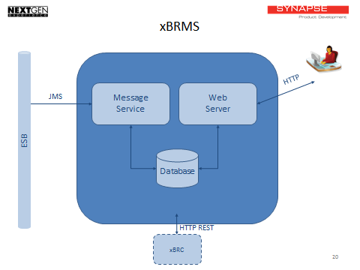

‘**Figure 4 – xBRMS Components**

The xBRC with its connecting pieces:



‘**Figure 5 – xBRMS Connecting Pieces**

The Sonic ESB broker implements the JMS bus used by the xBRCs to communicate with the xBRMS and other upstream components. It is not needed if ESB brokers already exist in the host venue.

The YUM repository is a RedHat RPM repository that is used to distribute new versions of software to the xBRCs. Placing updated RPMs in the repository signals to the xBRCs that they need to download and install that software update. Additionally, the YUM repository can be used to distribute new software to xBRs and xTPs. This software will also be packaged as RPMs. These RPMs will simply install themselves as data files in the xBRC which, in turn, will recognize the updated data files as new firmware to push to the xBRs/xTPs.



‘**Figure 6 – xBRMS communications to the xBRC**

## GxP Test & Survey

The GxP Test & Survey (GxP T&S) is scheduled to run from May 1 – May 15. The trial will involve DME guests scheduling GxP Experiences (i.e. FastPass+) for attractions at Magic Kingdom (MK). A percentage of DME guests will be chosen to participate in the GxP T&S. There will be 10 Attractions in Magic Kingdom to choose from and guests will select 4 FastPass+ attractions which will be scheduled across the course of single day during their visit. Once the guest chooses their FastPass+, they will receive a RFID enabled card with their attraction entitlements. One person per group will be designated at the lead guest. The lead guest will then receive an email with their schedule (guest name, name of attraction, date and time).

The process will look like this.

1. Cast Members will select registered Guests at the airport and off them a chance to participate in the GxP T&S. Guests will then enter in their name, email and select four attractions they would like to visit during their stay. Once the attractions are selected by the Guest, the Cast Member will add this information to an RFID card which will function as their FastPass+.
2. Guests participating in the GxP T&S will be able to enter the FastPass line by touching their RFID card at the Entry xTP installed at the beginning of the queue. The Guest will see a green light if their entitlement is valid.
3. Guests will also touch an xTP located at the merge point which is where the FastPass and Standby lines meet. The xConnect system will be able to track abandonments, and eventually be used to compare time between Standby and FastPass lanes.

The entitlements are tracked by GxP SOR (system of record). This short range read will check the GxP SOR to validate the entitlement. This process is called redemption. If the FastPass+ is valid, they will see a Green Ring light up on the xTP. If the FastPass+ is invalid, a Blue Ring will light up (commonly referred to as “Blue Lane”). If a Blue Lane event occurs, a Cast Member will intervene and look into why this process failed. The Cast Member has the ability override the Blue Lane if they so choose. Blue lanes can occur because of invalid entitlements, wrong day, wrong hour, wrong attraction etc.

The xConnect system will receive this data to both validate the entitlement as well as visualize the guests in the queue. This visualization is done with the xi module and screens that Synapse is developing.

* Around 4000 Guests per day will participate (66% of the 6000 daily DME guests).
* Guests will be given RFID card (no MagicBands) to record their entitlements on their card.
* The UIE Cast App is used to allow guests to choose up to 4 FastPass+ attractions at Magic Kingdom.
* The Cast App will run on a DLI 9000 device.
* Entitlement information is generated by the GxP module.
* IDMS takes and stores this entitlement information.
* UIE Cast App will read the data from IDMS and associate the entitlement (FastPass+) to a Guest.

Ten Attractions at Magic Kingdom will be used for the GxP Test & Survey.

* Entry and (1) Merge xTP will be at each attraction FastPass+ queue.
* Big Thunder, Buzz Lightyear, Haunted Mansion, Jungle Cruise, Peter Pan, Philharmagic, Pooh, Space Mountain, Splash Mountain and Town Square Theater (Mickey Meet and Greet).
* Mobile GxP (DLI 7200) wireless device will be used at 2 attractions for redemption.
  + The GxP T&S will utilize four Kiosks where Guests can touch and see their entitlements on a tablet device.

10 Attractions at Magic Kingdom (MK) that will be part of the GxP Test and Survey

|  |  |  |  |  |
| --- | --- | --- | --- | --- |
| **Id** | **Long name** | **Short** | **Reader Type** | **Kiosk Reader** |
| 1 | buzz lightyear | buzz | Mobile DLI 7200 | No |
| 2 | haunted mansion | hm | xTP | No |
| 3 | jungle cruise | jung | xTP | Yes |
| 4 | peter pan | pan | xTP | No |
| 5 | philharmagic | phil | xTP | No |
| 6 | space mountain | spce | xTP | Yes |
| 7 | splash mountain | spl | xTP | No |
| 8 | winny the pooh | pooh | xTP | Yes |
| 10a | town square minny | minnie | Mobile DLI 7200 | No |
| 10b | town square mickey | micky | Mobile DLI 7200 | No |

## GxP Survey & Test Schedule

GxP Test & Survey is scheduled to run for 2 weeks starting May 1, 2012

# Park Entry Pilot (July / August 2012)

Similar to the Park Entry implemented at Epcot in November 2011. Guests participating in the pilot will be able to enter Magic Kingdom by touching their RFID cards to xTP (DAP) installed at the Park entrance.

There are no MagicBands used for this test.

Program Owner: Mark Lewis (NGE)

Systems Used:

* Synapse - (xBRC), DAP (xTP+Bio)
* OmniTicket (ATS) / TORR – Automated Ticketing System
* Biometric component (Lumidigm)
* CastApp UI (Bluelane functionality) written by Trifecta

The process to enter the park for the Park Entry looks like this

* Guest is asked to participate in the Park Entry Test by a Cast Member.
* Guest then receives their RFID card before entering park and their finger is scanned for the biometric read.
* The Guest then walks up to the MET-3 entrance where they are met by a Cast Member and directed to touch their Card on one of the xTP’s. For MET-2, There were 4 xTP’s per side, 8 total at the entrance of Epcot.
* After tapping their card on the xTP, the Guest will put their finger on the fingerprint scanner to be validated
* If the RFID Card and Fingerprint are valid, the user will see a green light on the xTP and now be allowed to walk into the park.
* If the xTP turns blue, this is called a Blue Lane and the user must then engage with a Cast Member to see why their card or fingerprint failed. The Cast Member then interacts with the Trifecta Application to determine the cause of the failure.
* The Cast Member can review the reason codes and take appropriate actions.

## Park Entry Schedule

Dates have not been locked down for the next Park Entry pilot. The latest information has this scheduled for June 2012.

# Test Track Pilot (July 2012)

This is an Epcot experience that will be using cards issued by Chevrolet (rather than xBands) for some automobile designer/car customization experience. Guests will visit and interact with various stations and check in with the tap cards. The experience will need to utilize the new multi-media xTPs and back-end Synapse pieces to collect data and associate it with a given card.

# GFF Pilot - Be Our Guest (Nov 2012)

# Test Objectives & Methodology

All documented functionality and requirements from the Synapse product backlog will be considered within the scope of this release, and thus within the scope of this high level test approach. Any additions or modifications to requirements will be handled through the defined change control process.

## Test Objectives

The overall objective of the testing phase is to ensure that the xConnect system functions as designed in a controlled environment. A successful testing effort of Synapse modules will result in a system that is ready for integration testing with the Alpha Lab (Integration Testing Lab at Disney). Testing will ensure the following:

* Synapse business requirements are implemented and satisfied.
* Synapse functional and technical specifications are implemented properly.
* Errors and exception cases are handled properly.

## Test Planning and Preparation, Key Activities & Tasks

1. Creation of Synapse Test Plan (this document)
2. Design Docs and Requirements – validate design documents by comparing against requirements.
3. Design & Build Test use cases for testing
4. Design Test Data – create or acquire the data to be used in the test cases.
5. Prepare Test Environments - (BVT, SIT, INT, Alpha, Park LDU)
6. Build Test Scenarios - A test scenario is a high-level description of a specific piece of functionality to be tested. Each scenario will then drive one or more test scripts. Test scripts can then be mapped back to technical and business requirements.
7. Build TCER’s (Test Cases and Error Conditions)
8. Create and Deploy Test Data
9. Run BVT tests
10. Run Functional Tests
11. Run SIT Tests
12. Run UAT (User Acceptance Tests)
13. Implement Defect Tracking Progress (Fogbugz)
14. Run Load and Performace Tests
15. Define Test Conditions and Scripts - A test condition describes what causes the condition to occur and the expected result that will be validated against the actual result generated by test execution. A group of test conditions that need to be executed will represent a test scenario.
16. Test Automation Script Creation - Test scripts will be documented and maintained in Excel (manual tests) and written in Selinium (automated tests).
17. Test Automation Execution – Selinium will be used to run automated tests.

## V-Model

The left side of the V consists of the requirements gathering, high level design, and detailed design efforts associated with creating a new software application. The right side of the V consists of all the testing stages that should be executed when developing and testing the components and functionality that comprise the software application.

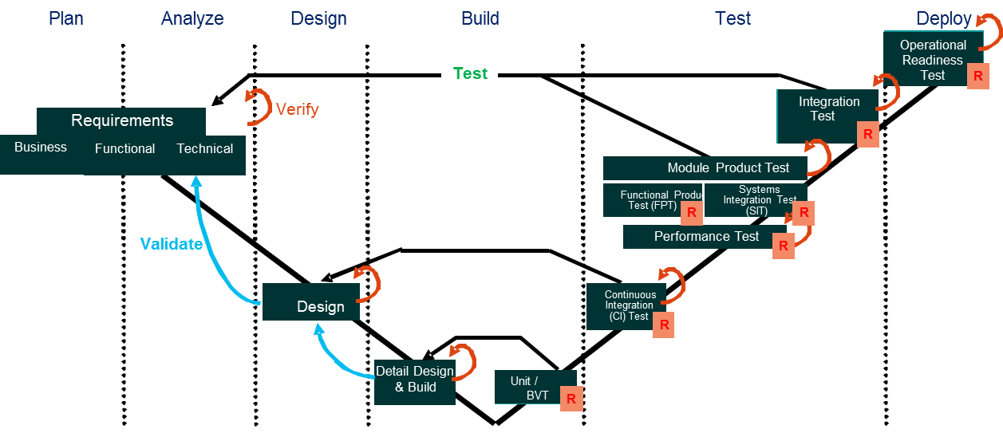

‘**Figure 7 – V Model**

## Test Planning Documents

| Document | Description |
| --- | --- |
| Synapse Test Plan and other test plans | This document will provide details around specific testing timelines, testing resources, areas of coverage, test types, external partners, etc. It will contain pointers to the various test approach strategies for xBR & xTP, xBRC, xBRMS, IDMS. |
| Test Scenarios, Conditions and Expected Results | These documents will provide details around the test scenarios that need to be tested along with the conditions and expected results that should be met in order to successfully validate each scenario. Each major module will have its own test plan. |
| Manual and Automated Test Scripts | This document will provide a set of test scripts that contain the specific steps that a testing resource must follow in order to successfully validate each test scenario. Test scripts will be created for each test stage. |
| Test Data | This document will consist of specific test data that should be used when executing test scripts for each test stage. |
| Testing Status Report | This weekly status report will track the progress of testing. |

# Build Process

The following section describes the build process.

## Synapse Builds

Builds are created every night using Cruise Control and packaged into RPM files.

RPMs are off the root directory called \Builds.

* The build will be pushed out to the YUM store on the BVT lab bench. It will then have to pass automated and manual BVTs.
* The BVT is executed and the results logged.
* Report – BVT reports are available for any recent build but won’t be emailed out (except possibly failures).
* Test Roll – a recent build that passed BVTs will be pushed to the Functional Stamp YUM server and deployed for further testing.
* The build will then be pushed to the SIT lab (fully on the Disney RH images) and automated BVT and LOAD tests run overnight.
* Successful deployment to SIT will be followed by a push to the INT (Integration) lab and BVT and LOAD tests run there overnight.
* Testing is then packaged to fit on the Alpha Lab VM by overlaying on the IDMS VM and IDMS SQL box as the test fixture.

## Setup of the xConnect System

There is a separate install document (Alpha Lab Installation Document) that covers the setup and configuration of the Synapse software modules. The list below contains modules from external partners GxP, FourWinds, Trifecta and UIE.

This high level install list is targeted at the GxP Test & Survey being installed in the MK LDU.

1. Install the xBRC application.
2. Install the xBRMS application and database. One xBRMS is used per xConnect System.
3. Create the YUM repository.
4. Install the IDMS application & SQL database. One IDMS is used per xConnect System.
5. Install as many xBRC instances as required. There is one xBRC per attraction.
6. Install MySQL for xBRC.
7. Install TCServer (NGE’s Tomcat Server).
8. Install the JMS listener.
9. Install xi.
10. Install Synapse hardware, xTPs (entry and merge locations) and xBRs at Haunted Mansion).
11. Install Test VM’s, MS SQL and Test Data.
12. Verify and Configure xBRC, xBRMS, xTP and IDMS.
13. Install GxP DAP UI, GxP SOR.
14. Install UIE Cast Application on the DLI 9000.
15. Install UIE Server.
16. Install Four Winds Application on the Kiosk.
17. Install GxP Mobile Reader on the DLI 7200.
18. Create Offer Sets (FastPass+) for Testing.
19. Configure QIP Server (addresses for hardware and xBRCs)

# Test Automation

Goal - to have specific test cases that will simulate reader events which in turn will generate xBRC events which will generate JMS messages and make calls to external APIs.  This gives us the flexibility to explore a full complement of functional test cases.  We’re building our automation framework on Selenium with a robust reader simulator. The simulator is capable of both staying connected to the xBRC correctly, and replaying reader events on command.

The core test framework for automation is [Selenium](http://seleniumhq.org/) with [node.js](http://nodejs.org/). This enables the core test type of web based query/response over HTTP, HTTPS, REST, SOAP, or similar. Additional tools and simulators will have REST or HTTP endpoints added to enable remote control support.

The core load test framework is driven by a centralized SQL server with a model of a full day in the park including real attraction metrics. This SQL Server manages the data setup and timing loops to ensure that all events are sent at the expected times.

A software reader is a simulator for a single short range read (xTP) or a long range read (xBR). The sequence of reads complies with the base set of timer based messages and can send events to the xBRC. These events typically come from one of two sources: a local MySQL test database or a remote source making a REST call.

A hardware reader is capable of taking a REST call to generate events for testing purposes. This makes the tests capable of using either final hardware or soft readers easily.

# Other Test Documents

## xBand (xB)

**See xBand Test Plan** (xBand not part of GxP Test and Survey)

The main purpose of the xBand is to transmit periodic packets containing a long-range ID (LRID) number unique to each xBand, to be received by the xBR. In addition, the band provides a small amount of status information to be used in diagnosing problems and estimating remaining batter life. The xBR (w/ the xBRC) uses this information to singulate the xBand to a specific location or area.

The xBand responds to a set of commands from the xBR that modify its behavior - increasing or decreasing the wakeup interval, activating and deactivating band transmissions, and changing the transmit power.

There are two types of packets. Those transmitted by the xBand are referred to as "Traffic Packets" or "Ping Packets." Those transmitted by the xBR are referred to as "Control Packets." Both Traffic and Controls Packets are 15 bytes in length.

The xBand can currently operate in one of four modes.

|  |  |  |  |
| --- | --- | --- | --- |
|  | **xBand Tx & Rx Modes** | The Range that xBR can be set to Ping or Receive Window (once every ? ) | Programmed setting for how long xBand stays in each mode |
| 1 | Programmable Transmit (Tx) | **100ms** – 10s | **1**-30 seconds |
| 2 | Fixed Transmit (Tx) | **1** second | 1-**30** minutes |
| 3 | Programmable Receive (Rx) | **1**-5 seconds | 1-**180** minutes |
| 4 | Fixed Receive (Rx) – Factory Setting | Once every 30 seconds | Until battery runs out |

Note: Default parameters for Modes 1, 2, 3 are in **bold**

**Default Mode:** When a xBand falls out of one of the modes above (1, 2, or 3), it will default to Receive once every 5 seconds for 180 minutes (Duration).

Hardware Test Types

DVT – Device Verification Testing.

PVT – Production Verification Testing.

Testing areas of focus…

Verifying traffic generated from the xBand is in the correct format.

Sending Control Packets from the xBR to the xBand.

Testing Modes 1, 2 and 3.

Sending a series of commands.

Sending commands to one xBand, sending to all xBands.

Exercise Global Command (See xBand Interface Control Document.

## xBand Touch Point (xTP)

See the 900-0074 Rev 1.0 xTP Test Plan

**xTP**

The xTP reader is used for park entry and to enter the FastPass+ queue at a park attraction. The xTP reader is one component of the overall xConnect project. xTP’s can be configured for Park Entry, FastPass+ Queues or other areas like resturants (GFF program). The xTP will detect an RFID card or MagicBand from an inch or two away in order to read ID information.

An xTP is associated with one xBRC. A xBRC assists in determining entitlement status for a guest by placing JMS messages on the ESB (Enterprise Service Bus) which are then consumed by other downstream applications (xBMS, GxP, xi etc.).

When used for Park Entry, the xTP has a biometric reader attached. When a Guest enters the park, they are required to touch the xTP with an RFID card / MagicBand and provide a fingerprint. Guests who are children do not need to provide a finger print. The xTP sends events to the xBRC which will then determine the status of the Guest via integration with the OmniTicket system. The xBRC tells the xTP reader to light up with appropriate colors, sequences and sounds. A green light indicates successful entry and a blue light indicates there was an issue with the Guest’s pass.

When used at an attraction, the RFID card / MagicBand is used for entry into the FastPass+ queue. The queue has an entry point and a merge point. It is at the merge point that the standby queue meets with the FastPass+ queue.

## xBand Reader Controller (xBRC )

See xBRC Test Plan

The xBRC is the main conduit for xBand *events* to be communicated to downstream applications that need to act on those events. An xBand event begins with a park guest nearing an xBR long-range reader or tapping an xTP reader. Events are sensed by the reader and then communicated to the xBRC. The xBRC processes events from multiple readers then (possibly) generates JMS messages to the Sonic ESB (Enterprise Service Bus). Downstream applications that are interested in the JMS messages produced by the xBRC can *subscribe* to this data using the “Sonic MQ” message broker. The message broker a component of the Sonic ESB

A module that expects to receive messages via HTTP registers itself with the xBRC as the sole recipient of messages; the HTTP mechanism, unlike the JMS mechanism, is one-to-one rather than one-to-many.

There are currently 3 different configurations for an xBRC

1. Park Entry Model (Park Entry Pilot).
2. Attraction Model (GxP Test & Survey).
3. Space Model.

**Opening screen of the xBRC Management System**

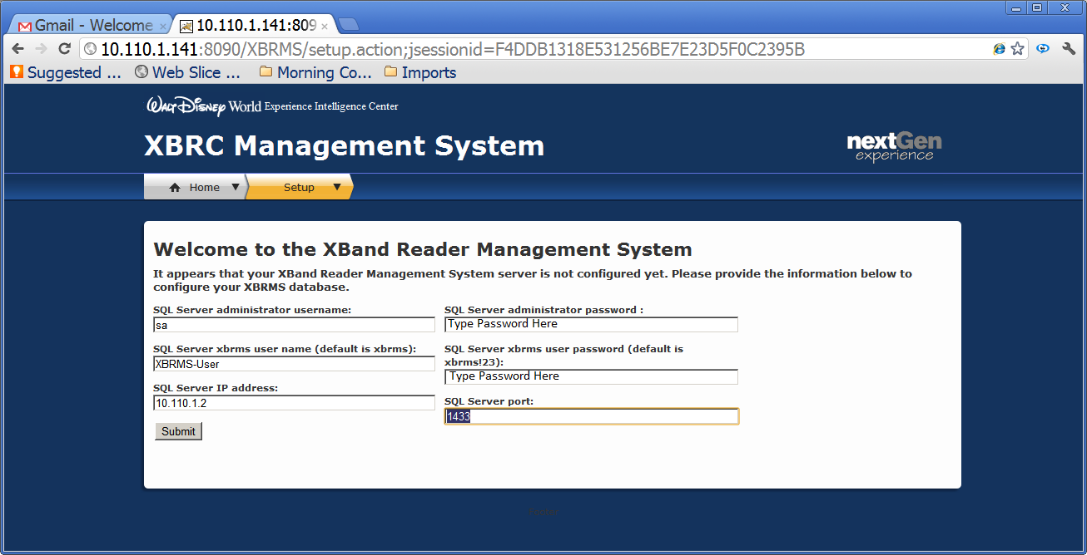

**Figure 8 – xBRC Management System**

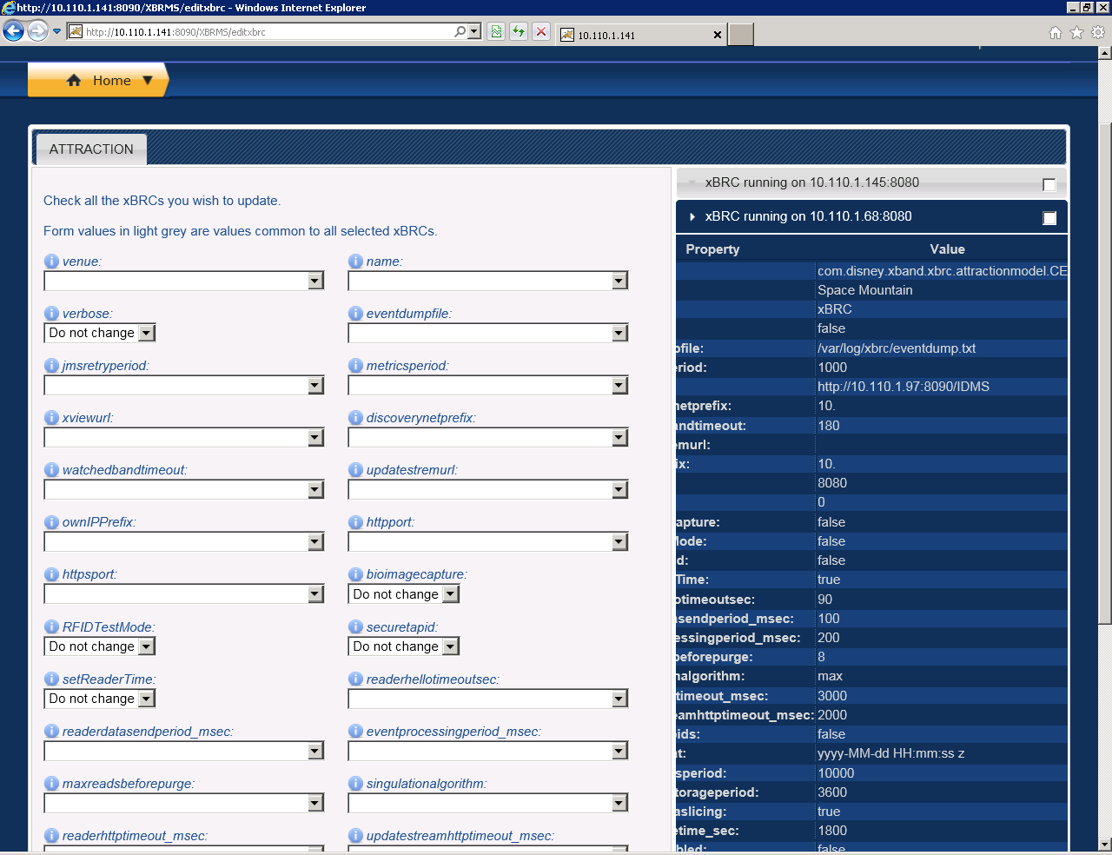

**Figure 9 – xBRC Management System 2**

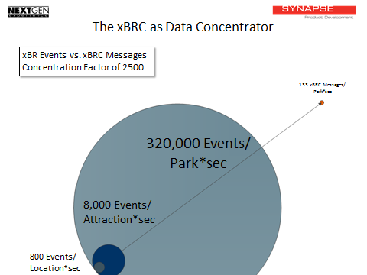

**Figure 10 – xBRC as Data Concentrator**

This chart represents the total number of xBand Long Range Reads for 40 Attractions.

* Each band chirps every second.
* Each xBR location includes eight radios “listening”
* Assuming 100 people within range of an xBR, the xBR hears 800 chirps per second
* Assume 10 xBR locations per attraction, gets you to 8,000 events per attraction per second
* Assume 40 attractions in the park that gets you to 320,000 events per second.

## xBand Reader Management System (xBRMS )

See 900-0072 Rev 1.0 xBRMS Test Plan

xBRMS is a collection of programs that support the xBRC and related modules. The UI of the xBRMS allows for the following functionality:

* Isolate the xBRCs from details of integrating with park or DCL back-end systems
* Monitoring System Health
* Manage xBRC, xBR and xTP software updates
* Auto Discover of xBRC via JMS message
* Capture and archive JMS events generated by the xBRCs
* Guest Search (by name)
* Storing, removal and deployment of xBRC Configurations
* Editing of xBRMS properties (JMS Broker, IDMS,xBRC UI)

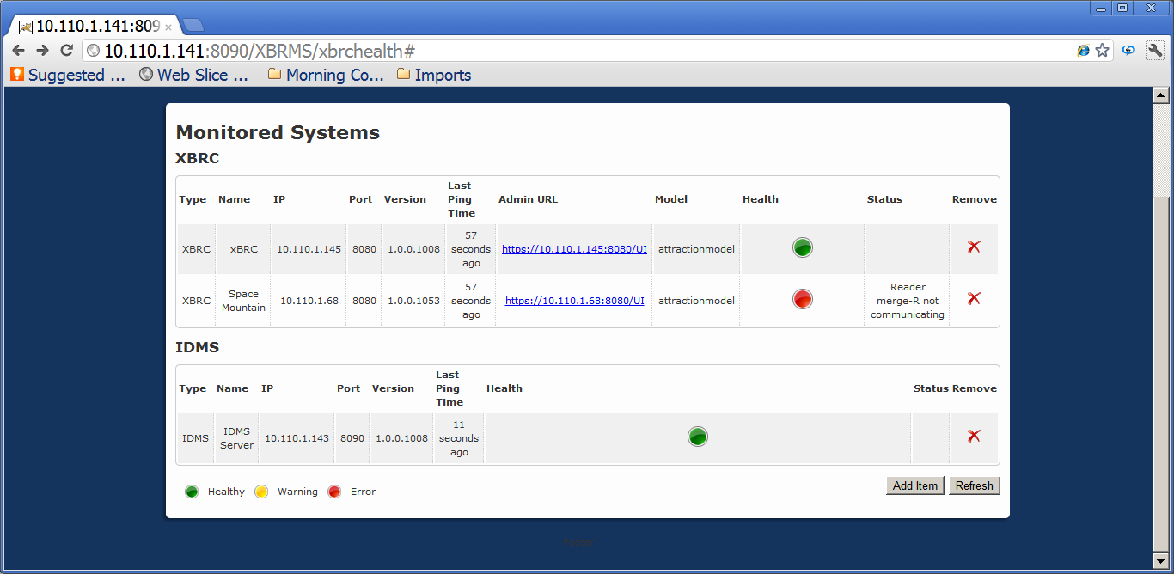

**Figure 11 – Monitored Systems**

## Identity Management System (IDMS)

See 900-0063 Rev 1.0 IDMS Test Plan

IDMS is an ID to ID management system. It is a type of lookup or “phonebook” for various systems to lookup data in other systems. It isn’t a repository of guest data, nor is it meant to be a cache of any systems of record (SOR) – it is meant to allow one system to associate (register an ID) and lookup an ID from an external system and retrieve necessary data from that SOR.

IDMS was developed using Java with the Open JDK 1.6 for Ubuntu in an Eclipse Indigo development environment. IDMS operates as a servlet, with Apache Tomcat 6 acting as the servlet container providing a REST API over HTTP/S.

IDMS uses MS SQL Server to provide database services through TSQL Stored Procedures and parameterized SQL statements with JDBC.

IDMS has two components; a middle tier library called IDMSLib.jar and the IDMS application. The IDMS application is a RESTful API over HTTP. The API uses standard HTTP, mapping its calls to GET, PUT, POST and DELETE calls and responds with HTTP headers, response types and response codes. This is accomplished using the Jersey JAX-RS implementation.

# Test Types

|  |  |
| --- | --- |
| **Test Type** | **Description** |
| Wireshark on ICD | Watch the messages come and go on the network (write out as samples in ICD). |
| Build Verification (BVT) | Build verification test validates all services and web pages are live and showing data, all core user scenarios are available and may require a small data set within the data stores to execute. |
| Upgrade | Verify v1.0 to v2.0 upgrade for park installations, v0.91 to v0.92 upgrades for daily builds, and rollback from v2.0 back to v1.0 |
| Functional / Regression (AUT) | Functional / regression tests: positive and negative tests executed in Selenium. |
| Environment Verification (EVT) | Environment verification to prove a deployment successfully started all external dependencies on all services on each VMs (goes through load balancer - not just by Virtual IP). |
| Load | 72 hours of successfully handling a typical day in the life of the park data model with 10 attractions. |
| Integration (INT) | Run BVT/Functional tests against final hardware and live partner services. |
| End to End / Scenario | Manual end to end tests within the HowVille lab including cast member and guest actions. walking around with RFID cards and Integration with hardware and devices. |
| Error | Test error path generation and recovery (generate most error conditions) and expose errors to partners and operations dashboards in actionable formats. |
| Failover | Detect box failure and switch over to backup boxes. |
| Security - Secure ID, User Roles | Verify that each user role has the appropriate permissions and does not have extra permissions to secure files; test HTTPS transport, certificates and protection and encryption of the Secure ID. |
| Final Assets | Verify facility maps, and other deliverables for the delivery. |
| Stress | 3x the typical LOAD test. |
| Performance | Integration of external components against performance requirements for guest experiences. |
| Deployment Walkthrough | Inspect box for extra installed files, tables, etc. |
| Code Walkthrough | Inspect code for TODO, logic, etc. |
| Network Utilization | Study TCP traffic volume and recommend reduction strategies. |
| Unit | Developer crafted unit tests with data injection. |
| Security – Penetration | Penetration testing against cross site scripting, sql injection, etc. |

# NGE Testing

NGE Testing is done by three main groups

1. Module Developers are responsible for Test-Driven Development**.**
2. Module Testers will be responsible for planning and executing Functional Tests at Module level (MPT).
3. Program QAis responsible for planning and executing Functional Tests across Modules (SIT); including Regression tests.

Program QA’s role is to provide guidance and monitor adherence to the testing program principles to, each Module during development Test Driven Development (TDD), Unit Testing (UT), Assembly Testing (AT), and Module Product Test (MPT)) in order to facilitate the Module SIT participation.

## Core NGE Test Phases

**Module Product Test Team (MPT)** – Tests that individual modules meet their individual functional requirements L4. Tests the business requirements are met by the individual application. (xBMS, GxP, etc.).

**System integration Test (SIT)** - System Integration Testing will serve as the validation that all delivered functionality will operate as designed when integrated with other modules and provide a continuous flow of data through the NGE system.

**Performance Testing (Perf)** - Tests that the system is capable of operating at the load levels specified by the performance requirements and any agreed upon Service Level Agreements (SLAs). No significant changes should be made to the system once Performance testing begins.

**User Acceptance Testing (UAT)** - Ensures that the users and stakeholders are satisfied with the solution. For CAST, it enables the end users to complete a review of the system prior to deployment. Major changes should not be made to the system at this point.

**Operational Readiness Tests (ORT)** - Confirm successful deployment in Guest and Cast Areas.

## Other Test Phases @ NGE

**Mobile Testing** will fully prove out requirements both functional and non-functional associated with L4s enabled by the module. Cross module integration will be stubbed out for this test.

**Disaster Recovery Testing** is typically used to prove nonfunctional requirements associated with manual and technology solutions to allow for continuity in the case of hardware failure. This test can cover the range from the outage of single server to the loss of a data center.

**GBTS** is associated with the testing of the legacy systems. GBTS is responsible for fully testing all changes to legacy applications. Once NGE is live they will also be responsible for regression testing changes to their systems with NGE.

**Security Testing** is associated with verifying that all software and hardware meets associated nonfunctional requirements associated with securing NGE capabilities from theft.

## NGE Build and Configuration Management

The Build Configuration Management team handles packaging/deploys for controlled environments

|  |  |  |
| --- | --- | --- |
| Environment group | NGE Env | Desc |
| TEST | ENV 1 | Formerly called SIT |
| TEST | ENV 2 | Formerly called UAT |
| TEST | ENV 3 | Formerly called LOAD |
| TEST | ENV 4 | Formerly called DEMO |
| PROD | ENV 5 | STAGE/PRE-PROD |

The current modules handled by the Build Configuration Management Team are:

[**SF OV/RTI**](https://wiki.nge.wdig.com/display/NGE/Strategic+Functionality)

[**GxP (xPass)**](https://wiki.nge.wdig.com/display/NGE/Guaranteed+Experiences+%28GXP%29)

[**xBand/xBMS**](https://wiki.nge.wdig.com/display/NGE/xBand)

[**Cast App (aka C2 – Cast Capabiltities)**](https://wiki.nge.wdig.com/display/NGE/Cast+Capabilities+%28C2%29)

# NGE Test Environments

## Alpha Lab (Disney Staging Lab)

See the 900-0033 Rev 1.0 NGE Alpha Lab Installation

## Testing Environment Descriptions

|  |  |
| --- | --- |
| Environment | Description |
| Development Workstation (IDE) | This environment will be used to conduct development, unit testing, designs, etc. |
| Assembly Test (AT) | This environment will be used to ensure the components compile together and will be used to execute Assembly test. |
| Module Product Test (MPT) | This environment will be used to execute application product testing. |
| System Integration Test (SIT) | This environment will be used to execute the integrated application product Testing. |
| User Acceptance | This environment will be used to support user acceptance testing. |
| Load Test | This environment will be used to support performance testing |
| Staging/Demo | This environment will be used to support operation testing and pre-production activities |
| Release Lab | This environment will be used for demo simulation of the accepted application product |
| Production | This environment will support the final application product |

|  |  |  |  |  |  |  |  |
| --- | --- | --- | --- | --- | --- | --- | --- |
| Testing Function | Unit Testing | Assembly Testing (AT) | Continuous Integration | Module Product Test (MPT) | System Integration Test (SIT) | UAT | Performance Test |
| Purpose | To validate individual components. | To test the interaction of related components within an application. | To demonstrate that the modules that collectively make up an application/  system. | To test functionality of individual module with stubbed interfaces to adjacent systems based on specific module requirements. | To test functionality within and between applications, assuring the system meets application group and system requirements. | Conducted to validate that the system meets documented business and user requirements. | Performance testing identifies and fixes system performance issues before the system is deployed. |
| Lifecycle Phase | Daily Development | Throughout Sprint | Throughout Sprint | End of Sprint | After two Sprints | End of Iteration | End of Iteration |
| Environment | Developers IDE | Assembly Test | CI | Module Product Test | SIT | UAT | Load Test |
| Interface/Data | Stub | Stub | Stub | Stub | Integrated with SORs leveraging CIAB | Integrated with SORs leveraging Home base | Integrated with SORs leveraging Home base |
| Owner | Developer | Developer | Developer/QA | QA | QA | QA | QA |

# Synapse Test Environments

## Build Verification Environment (BVT)

* Purpose: new builds are first installed on this environment and smoke tested.
* Migration: installation, BVT, and 1 hour LOAD test must complete successfully.
* Description: This environment is a small environment of about 10 VMs which include two attractions, a kiosk and a park entry xBRC. All readers are simulated.

## System Integration Testing (SIT)

Purpose: active testing bench for manual and automation tests

Migration: installation, BVT, SIT, and 8 hour LOAD, and 1 hour of manual testing must complete successfully.

Description: This environment is a small environment of about 10 VMs which include two attractions, a kiosk and a park entry xBRC. All readers are simulated except one hardware xTP which can be swapped in and out. This also includes UIE, GXP VMs.

## Integration Testing (INT)

* Purpose: active integration bench for interactive use of hardware readers
* Migration: installation, BVT, SIT, and 24 hour LOAD, and 48 hours of manual testing must complete successfully.
* Description: This environment is a large environment of about 20 VMs which include all 10 attractions, a kiosk and a park entry xBRC. All readers are hardware where available and DLI readers are simulated. As hardware migrates to Orlando, more readers will be simulated.

Create an end to end system that can accurately test Synapse hw/sw with external partners.

**Physical Locations for Testing**

1. Synapse HQ - Seattle
2. Synapse Lab – “HowVille”, South Seattle (SODO)
3. Disney – Alpha Lab, Orlando

Components:

* GxP Inventory - manages how many entitlements are available and what hours they can be redeemed.
* GXP Redemption SOR and Service: (on GXP VM) is an Oracle DB and RESTful service that provides verify and redeem and override endpoints.
* GXP DAP UI: (GXP VM) provides a webpage to the cast member to override or reject a guest. Serves both lanes at the same location.
* xTP: Short Range Reader - Touch Point
* xBR Long Range Reader – xBand Reader
* UIE Cast Application (WebVan) used at DME for creation and association of entitlements to Guests. Runs on DLI 9000 Windows Device.

**Test Scenarios**

**Touch to Verify:** a touch on an xTP results in the xBRC calling GXP to verify an entitlement for a band/card at an attraction at a time. This can be done multiple times without consuming the entitlement.

**Touch to Redeem:** a touch on an xTP results in the xBRC calling GXP to redeem an entitlement for a band/card at an attraction at a time. This can only be done once and affects any entitlements on other cards for the same guest.

**Single Touch to Verify and Redeem:** a touch on an xTP results in the xBRC calling GXP to both verify and redeem and entitlement. This can only be done once as it clears the entitlement.

**Blue Lane Resolution:** the green/blue status of the touch is reflected to a cast member on the DAP UI provided by the same GXP system that is doing the redemption. The cast member can choose to reject the guest or to provide an override and let the guest in.

## Functional Tests / UAT (User Acceptance Tests)

**Objective**

The objective of UAT is to validate that the delivered functionality meets the desired Disney guest and Cast experience identified by the business requirements.

**Resources:**

Test Execution: Business Analysts, Program Managers, Operations (Infrastructure Team), Test Team

This group will focus on validating the Guest & Cast experience meet the requirements

**Environment:** UAT

**Entry**

* SIT Tests are complete
* Testing environment is available; Code migration complete; Test data is available
* Test scope is confirmed by participants
* Test cases are complete and test scheduled
* Participants confirmed to execute tests

**Exit**

* 100% execution of in-scope test cases
* No open Pri 1 and 2 defects

## Load & Performance Testing

### Test Description & Objective

In order to satisfy this objective, the following types of performance test will be executed.

* ***Baseline Test:*** Baseline test is undertaken to capture the average transaction response times without load (single user) on the system to be used as a benchmark to compare against subsequent performance test runs.
* ***Load Test:*** The purpose of the Load Test is to show the behavior of the system during normal usage/load that is anticipated by the project.
* ***Stress Test:*** Stress Test involves increasing the load being executed to determine the breaking point of the system.
* ***Stability Test:*** The purpose of Stability Test is to confirm that system performance does not degrade over time with a normal load. Stability test will be executed at the end of each iteration.

### Load Testing

 Contact: Amar Terzic [amart@synapse.com](mailto:amart@synapse.com)

Load test is designed to allow for triggering guest-like activity within xConnect and GxP systems for up to 10 Park attractions. Current scope of the data is limited to fast pass guests.

Load test data consists of synthetically generated fast pass entry and merge events for 10 attractions, and kiosk events for 8 kiosk locations. Data itself covers 6 days of non-stop park operation, or 10 consecutive park days without nightly closures. Corresponding GxP entitlements are derived from a load test data.

 Data is structured in a way to support following configurations

* Secure and non-secure xBRC operating mode
* Left and Right reader locations
* Ability to specify attractions and readers
* Ability to throttle the output
* Portability – easy to deploy

Data row count is roughly 3 million and it encompasses roughly 900K entitlements.

Data access is through stored procedure and output is defined by the input requirements of the test harness.

**GxP Entitlements**

 By design GxP database stores entitlements with respective redemption windows. To run end to end load test entitlements need to be present in GXPDAP schema. Currently this is accomplished by creating a table in GXPDAP schema and importing 900K entitlements from CSV file. After data is physically present in GXPDAP schema a sequence of data insert and update statements is executed in order to configure entitlements and apply time offset to sync entitlements up with the load test data. Initial GxP SQL code has been provided and approved by GxP development team.

**Deployment Steps**

 MS SQL Server to host Load Test database

* Server itself should allow remote calls from test harness. Specific SQL login needs to be created for this purpose.
* Preferably we would like to have ddladmin level of permissions on load test database. Anything above ddladmin is a bonus; anything below is a risk and might delay deployment.
* Able to import load test data from CSV file to a permanent table in load test database
* Able to create stored procedures and additional tables.
* Able to run queries and updates against load test data

**Test Harness Machine**

* Hosts test suite
* Needs access to SQL server, GxP Oracle Database Server – GXPDAP schema only
* Access to GXPDAP schema from SQL Developer query tool – port 1521, SID xe
* Able to import entitlements from CSV file to a table
* Able to create one stored procedure
* Able to be able to run queries, inserts and updates against tables containing entitlements

**GxP Oracle Database Server – GXPDAP schema only**

* We need access to GXPDAP schema from SQL Developer query tool – port 1521, SID xe
* We need to be able to import entitlements from CSV file to a table

We need to be able to create one stored procedure

* We need to be able to run queries, inserts and updates against tables containing entitlements
* We might need to add additional configuration data to GxP locations and operational schedules.

# Disney Environments

## Alpha Lab

See the 900-0033 Rev 1.0 NGE Alpha Lab Installation

The Alpha Lab is the staging environment before software and hardware are released into the Park LDU. The Alpha Lab is located in the Back Stage area near Magic Kingdom.

## Park LDU

For the purpose of this document, Park LDU is Magic Kingdom where the GxP Test & Survey will take place.

### In Park Testing for GxP Pilot and Survey

After hours testing done in the Park LDU before launch of GxP Test and Survey (April 2012)

|  |  |  |  |  |  |
| --- | --- | --- | --- | --- | --- |
| MK FP Test - In-Field Testing Scenarios  Saturday, 4/28/12 & Sunday, 4/29/12 5:00 AM - 9:00 AM | | | | | |
| **Scenario 1: Validate Green Lane for Volume** | | | | | |
| **Type** | **# of cards** | **# of People** | **Entitlements** | **Objective** | **Preparation / Action** |
| Non-Standard Entitlements | 10  (1 per attraction) | 10 | 1000 | Volume | Create 10 cards by 4/26 |
| **Scenario 2: Validate Green Lane for full offer set (previous & same day selection)** | | | | | |
| **Type** | **# of cards** | **# of People** | **Entitlements** | **Objective** | **Preparation / Action** |
| Standard Entitlements | 100  (w/sets) | 25 | 4 | E2E Guest Experience Full offer set redemption  (previous day selection) | Pre-select offer sets  Print confirmation w/card in envelope (vary attractions) |
| Standard Entitlements | 25 (w/sets) | N/A | 4 | E2E Guest Experience Full offer set redemption  (same day selection) | Select offer set Print confirmation w/card in envelope (vary attractions) |
| **Scenario 3: Validate Blue Lane & Overrides** | | | | | |
| **Type** | **# of cards** | **# of People** | **Entitlements** | **Objective** | **Preparation / Action** |
| Blue Lane - early | 20 (w/sets) | N/A | 4 | Validate reason code Confirm Cast App Verify override | 10 cards/no grant access by attraction 10 cards/grant access by attraction |
| Blue lane - late | 20 (w/sets) | N/A | 4 | Validate reason code Confirm Cast App Verify override | 10 cards/no grant access by attraction 10 cards/grant access by attraction |
| Blue Lane - please see kiosk | 20 (w/sets) | N/A | 4 | Validate reason code Confirm Cast App Verify override | 10 cards/no grant access by attraction 10 cards/grant access by attraction |
| Blue Lane - diff experience | 20 (w/sets) | N/A | 4 | Validate reason code Confirm Cast App Verify override | 10 cards/no grant access by attraction 10 cards/grant access by attraction |
| Blue Lane - already redeemed | 20 (w/sets) | N/A | 4 | Validate reason code Confirm Cast App Verify override | 10 cards/no grant access by attraction 10 cards/grant access by attraction |
| **Scenario 4: Validate valid look up, future date look up, non-entitlement look up** | | | | | |
| **Type** | **# of cards** | **# of People** | **Entitlements** | **Objective** | **Preparation / Action** |
| Kiosks (4) | 100  (w/sets) | N/A | 4 | Offer set look up  (valid entitlements) | Same cards/people from scenario 2 |
| Kiosks (4) | 25 | N/A | 0 | Look up (not valid entitlements) | Provisioned cards w/no entitlements |
| Kiosks (4) | 10 (w/sets) | N/A | 4 | Different day look up | Pre-select offer sets  Print confirmation w/card in envelope (vary attractions) |
| **Total # of People Needed:** |  | **35** |  |  |  |
| * xi dashboards/measurements will be validated throughout all scenarios to validate numbers | | | | |  |
| * Scenario 2, 3 & 4 will utilize same 25 people (envelope will have instructions and locations printed/prepped) | | | | | |

# Release Criteria for GxP Survey & Test

Test Exit Criteria:

* All scripts and manual tests have been successfully executed and have passed.
* All Priority 1 level defects have been fixed; regression tested and has passed.
* All outstanding Priority 2 defects have an appropriate work-around or a remediation plan has been defined.
* Any unresolved defects are fully documented and approved by the Program Management, Testing, and Development.
* All test environment clean-up tasks have been completed.
* All test scenarios, conditions, and scripts have been updated if any errors were identified during execution.

# Regression Testing

Regression testing ensures that when a change is introduced to a component (as a result of bug fixes or enhancements), it does not adversely affect the correct (or original) functionality of the application. Essentially, regression testing is *re-*testing that is traditionally conducted whenever a change or update occurs to the application. Each time new code is pushed, bug fixes are inserted, or a change is made to an interface, regression testing may be necessary. The Development and Test leads will be ultimately responsible for determining when regression testing is applicable, especially in the case of minor changes that may not require regression testing.

The Development team will be responsible for working with the Test team to communicate when new builds or fixes are pushed so that the Test team can regression test the parts of the system that have been altered or are impacted by the change. Existing automated test scripts will be reused wherever possible to conduct regression testing. The decision regarding the amount of retesting that should occur for a specific change will be determined jointly by the Development and Test teams. If agreement cannot be reached, the ultimate decision will lie with the Test lead. As regression testing scope gets larger, the use of automated tools such as Selenium will help to speed up the process.

# GxP Survey & Test Timeline

|  |  |
| --- | --- |
|  | Key Dates |
| BVT Test Complete | March 1st |
| Integration Testing Started | March 15th |
| Test Cases Complete | April 1st |
| Code Complete | April 13th |
| Release Candidate | April 20th |
| Integration Test Complete | April 27th |
| Release Final Build to Alpha Lab | April 20th |
| GxP Test & Survey | May 1st – May 15th |

# Test Roles & Responsibilities

The following teams and resources will be necessary to successfully plan, execute, and manage the overall testing effort for the Synapse Release 1.0 implementation.

| Team | Role | Task |
| --- | --- | --- |
| Synapse Development Team | Development Manager | Lead and manage the overall application build and fix effort. |
| Software Design Engineer | Develop and unit test Interface components. |
| Application Lead | Develop and unit test UI components; create appropriate test harnesses. |
| Synapse Test Team | QA Test Lead | Lead the preparation and execution of the module testing effort.  Review defects as they are identified and estimate the fix effort. |
| Software Design Engineer / Test Lead | Monitor testing processes to ensure that testing is following the program’s standards. |
| Performance / Load Test Engineer | Create Synapse detailed performance test plan  Prepare performance test material for all test stages:  Test Scenarios  Test Conditions & Expected Results  Test Scripts  Test Cycle Control Sheets  Test Data |
| Software Test Engineer | Execute test scripts |
|  |  |
|

# Test Setup

The following section describes the test setup process

# Test Environments & Labs

The following environments will be made available for testing purposes:

* **BVT Environment** – Build Verification Test
* **INT Environment** – Integration - This environment will be used by the Program to execute System Integration Testing.
* **SIT Environment**  - End User Testing: End to End function testing then promote to Production & Staging
* **Load** **Test** – Performance Testing: Used to run automated performance tests and then promote to Production & Staging.
* **HowVille**  **Lab –** Synapse Lab for staging prior to deployment in Alpha Lab.
* **Alpha Lab** – Final Staging before deployment into Production Environment.

### Test Management Tool

Excel, moving to Rally Testing Module

### Test Automation Tool

Selenium

### Performance Test Tool

TBD

# Test Data

Test data will be created to closely mimic business data to allow for a realistic testing experience. As part of the test data creation process, there will be a concept of a “test bed”, which consists of a pool of test data that can be managed and leveraged across multiple test scripts. Before the test bed can be created, all possible test data needs must be determined and added to a test data needs inventory. This needs inventory will drive the creation of the test data pool. Once the test data pool is created, test data will be associated to all applicable test scripts.

The following types of data will be necessary to execute the necessary tests:

* **Foundation Data** – provides basic test data which allows testers to execute test scripts and is generally static in nature. This foundation data will be referred to in the test scripts and it may be updated as required. Foundation data will be loaded into the system and refreshed during the plan/analyse portion of each iteration. The data must account for the iteration’s worth of data.
* **Historical Data** – will be entered into the system as necessary to allow for testing of certain functional areas such as reporting. This will provide sufficient mock-up historical data to test reporting. This data is relatively static.

Test data will be created prior to and during test execution in order to allow for all necessary test conditions to be properly tested. Also, test data and changes to test data will be tracked in an organized manner to allow for test recreation where necessary (i.e., when trying to recreate an error for a defect that has been found). The creation of test data will be the responsibility of both the Development team (for Unit and assembly test) and Test team (for all others).

# Configuration Management

The developers will use a centralized code repository (GIT) to manage codes that may be going back and forth between developers and testers, including code updates due to defect fixes.

# Test Control

## Defect / Issue Management

FogBugz is used to track to track all defects and issues at Synapse

Internal Instructions <https://wiki.synapse.com/display/Mayhem/FogBugz+-+Training>

Internal Database <https://synapsedev.fogbugz.com/>

Contact Synapse Testing for access.

## Change Request Management

The change control process will ensure proper traceability of all changes made during the build and test phase. It will consist of a formal submission of a change request through the Prioritized Backlog and will be managed by the Release Manager. All change requests will be reviewed by the Change Control Board, which will consist of necessary product owners and stakeholders. Change requests will be reviewed for priority and will either be accepted or denied/deferred based on level of effort (LOE) and necessity. All changes to current requirements and use cases must be approved through this process before they can be added to the testing scope.

# Terms / Definitions

|  |  |
| --- | --- |
| **TERM** | **DEFINITION** |
| NGE | Now known as My Magic+ |
| GxP | Now known as FastPass+ |
| PEP | My Disney Experience (external) Personal Experience Portal (internal) |
| API | Application Programming Interface |
| Auto Cancel | The process by which FastPass+ will be canceled if a Guest is no longer qualified. |
| GSR | Guest Service Recovery |
| Green / Blue Indicator | When a Guest touches at xTP or DAP, a green light indicates that there are no issues and the Guest may proceed as normal. A blue light indicates there is a problem that requires Guest assistance. |
| GXP | Guaranteed Experiences (internal) |
| Qualifying Resort Reservation | A resort reservation which meets the eligibility requirements for NGE. |
| R1A | Initial release of NGE to Guests who have a qualifying WDW Deluxe resort reservation, or who have previously qualified. |
| SF | Strategic Functionality |
| SOR | System of Record |

|  |  |
| --- | --- |
| IDMS | ID Management System (Synapse Test Harness) |
| NGE | Next Generation Experience |
| ICD | Interface Control Document (similar to API) |
| DCL | Disney Cruise Line |
| GFF | Great Food Fast |
| xi | eXperience Intelligence |
| xPass | eXperience Pass |
| xBand | eXperience Band |
| xTPE | eXperience Touch Point Enabler (aka DAP) |
| xTP | eXperience Touch Point |
| xB | xBand or MagicBand |
| xBR | eXperience Band Reader |
| DAP | Disney Access Portal, an xTP configured with a biometric reader. |
| xBR1 | Next generation xBR |
| xAP | Formally DAP |
| xBRC | eXperience Band Reader Controller |
| xPD | Payment Device |
| xBMS | eXperience Band Management System |
| xMR | Mobile Reader |
| Park Entry Model | Scenario where DAP reader is used at Park Entry |
| xTable | Product that is installed at a dining table and is a Long range tag transceiver data device in the xConnect system. The xTable is used to associate guests to a table. |
| xVehicle | Product that is installed on the ride vehicle and is a Long range tag transceiver data device in the xConnect system. The xVehicle is used to associate guests to a ride vehicle. |
| Attraction Model | Scenario where guest uses FastPass+ for an attraction |
| Entitlement | Any consumable product or service that a Guest considers a benefit, that can have a status of available, reserved (booked), redeemed (used) or expired. |
| non-standard entitlement | An entitlement that bypasses the business logic that governs standard entitlements.  It allows for testing after park hours as well as accommodating guests in special circumstances. |
| Singulation | The location of a single xBand within an attraction or in the park is singulation. The ability to distinguish one xBand from another with longer range reads is very use specific. The smallest location singulation is defined as a seat in an attraction. |
| Merge Point | Merge is where all queues merge into single queue prior to loading. |
| Load Point | The load area reads need to capture the Guest / xBand entering a vehicle rather than exiting the merge point. Most guests wait 1 to 5 minutes at the load point. |